**ASSESSMENT ON DATABASE**



**Problem Statement: There can be multiple customers, who can place multiple orders on the site. Now a sales person can handle these orders will distribute into multiple sales persons (One order will be assign to one salesperson only). So a sales person can have multiple orders of multiple customers**

**1.Create Database**

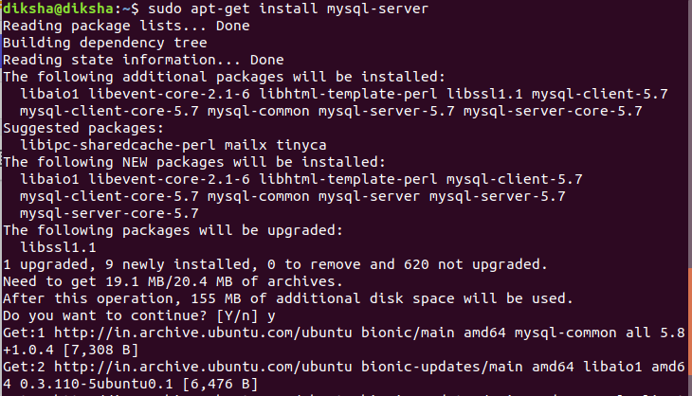

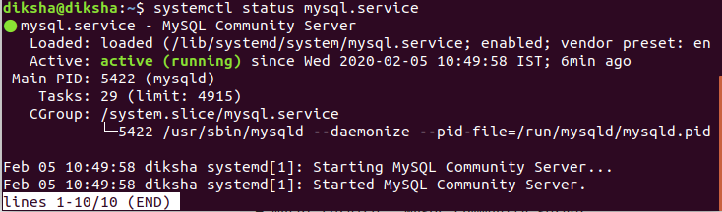



**2.Design Schema**



**3.Create tables**

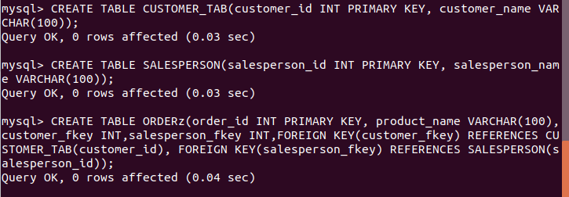

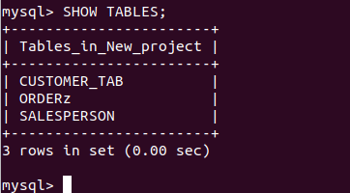

**4.Insert sample data**



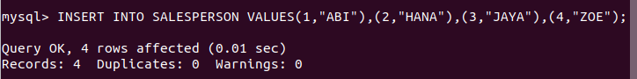

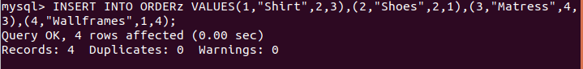

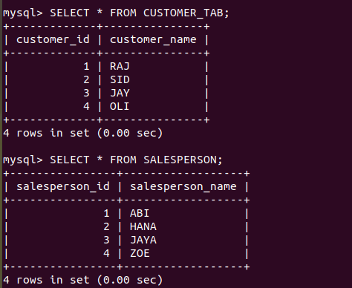

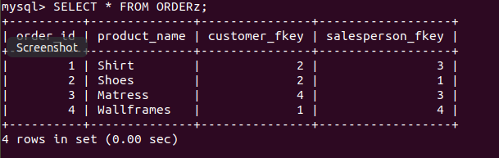

**5.Find the sales person having multiple orders.**

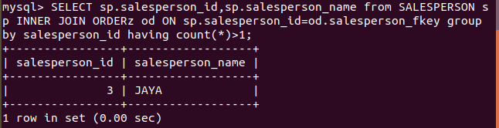

**6.Find all sales persons details along with order details**

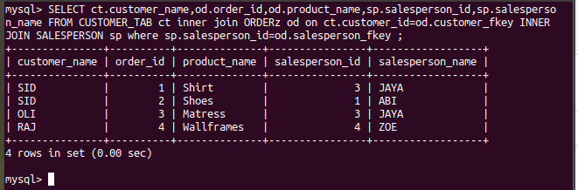

**7.Create index**

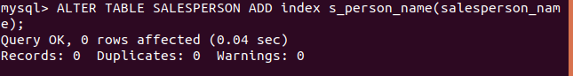

**8.How to show index on a table**

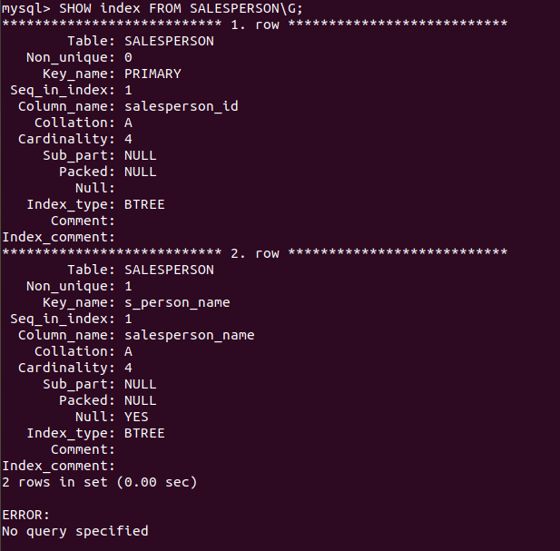

**9.Find the order number, sales person name, along with the customer to whom that order belongs to**

